Semester One
ATAR course examination, 2023
Question/Answer Booklet

PSYCHOLOGY - UNIT 1

Student Name _______________________________________________

Time allowed for this paper
Reading time before commencing work: ten minutes
Working time: three hours

Materials required/recommended for this paper
To be provided by the supervisor
Question/Answer booklet

To be provided by the candidate
Standard items: pens (blue/black preferred), pencils (including coloured), sharpener,
correction fluid/tape, eraser, ruler, highlighters

Special items: up to three calculators, which do not have the capacity to create or store programmes or text, are permitted in this ATAR course examination

Important note to candidates
No other items may be taken into the examination room. It is your responsibility to ensure that you do not have any unauthorised material. If you have any unauthorised material with you, hand it to the supervisor before reading any further.

Structure of this paper

Section | Number of questions available | Number of questions to  be answered | Suggested working time (minutes) | Marks available | Percentage  of  examination
Section One  Short Answer | 6 | 6 | 120 | 128 | 70
Section Two Extended Answer  Part A | 1 | 1 | 60 | 30 | 10
Section Two Extended Answer  Part B | 2 | 1 | 60 | 34 | 20
Total |  |  |  |  | 100

Instructions to candidates

- The rules for the conduct of the Western Australian external examinations are detailed in the Year 11 Information Handbook 2023: Part II Examinations. Sitting this examination implies that you agree to abide by these rules.

- Write your answers in this Question/Answer booklet preferably using a blue/black pen.
Do not use erasable or gel pens.

- Answer the questions according to the following instructions.

Sections One: Write your answers in this Question/Answer booklet. Wherever possible, confine your answer to the line spaces provided.

Section Two: Consists of two parts. Part A with one question, part B with two questions. You must answer one question from each part.

- You must be careful to confine your answers to the specific questions asked and to follow any instructions that are specific to a particular question.

- Supplementary pages for planning/continuing your answers to questions are provided at the end of this Question/Answer booklet. If you use these pages to continue an answer, indicate at the original answer where the answer is continued, i.e. give the page number.

Section One: Short answer 70% (128 Marks)

This section has six questions. Answer all questions. Write your answers in the spaces
provided.

Supplementary pages for planning/continuing your answers to questions are provided at the end of this Question/Answer booklet. If you use these pages to continue an answer, indicate at the original answer where the answer is continued, i.e. give the page number.

Suggested working time: 120 minutes.

Question 1 (32 marks)

The human nervous system is divided into two main systems, which can be further divided into another two each.

(a) Complete the missing sections of the diagram below. (4 marks)
Nervous system
C:
B:
D:
Somatic nervous system
Autonomic nervous system
A:

The autonomic and somatic nervous systems are further divided into two sections each.

(b) Contrast the autonomic and somatic nervous systems in terms of their functions.
(2 marks)

Question 1 (continued)

(c) State the function, and give an example for, the two divisions of the autonomic nervous system. (2 marks)

Division | Function | Example
Sympathetic
Parasympathetic

(d) Using the diagram below, label the effects the parasympathetic and sympathetic nervous systems would have on the body. (4 marks)

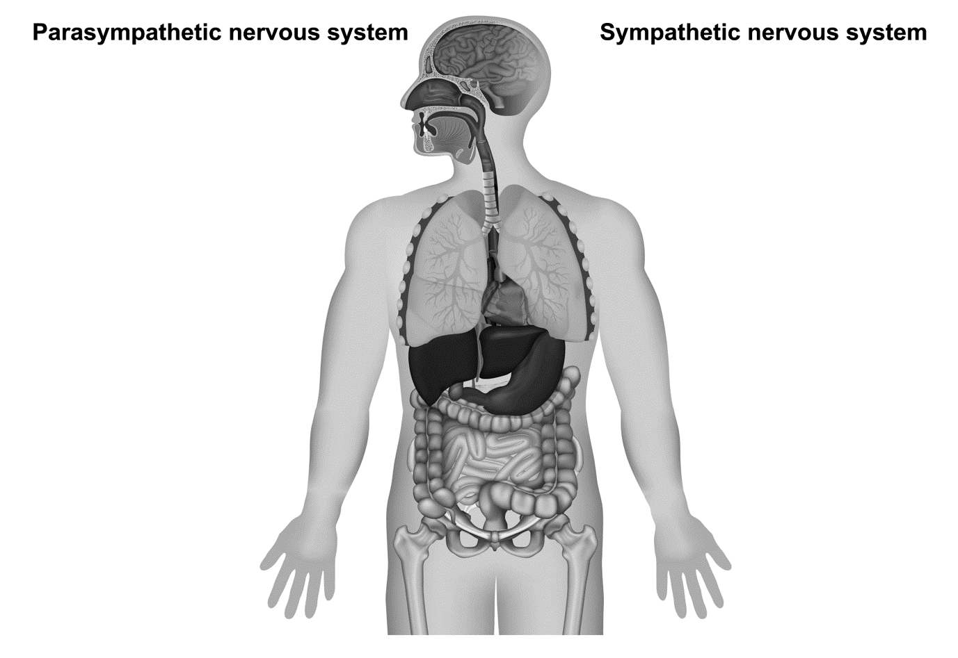
Eyes: __________________

_______________________
Heart: _________________

_______________________
Lungs: _________________

_______________________
Gut: ___________________

_______________________
Sympathetic nervous system
Parasympathetic nervous system

Dao is working in the garden when he is stung by a wasp on his arm.

(e) Name and outline how the two divisions of the somatic nervous system manage this experience, naming both divisions. (4 marks)
One:

Two:

In order to learn about the nervous systems, researchers have had to conduct studies with humans.

(f) List three roles of an ethics committee for psychological research. (3 marks)
One:

Two:

Three:

(g) State four pieces of information needed to be provided to participants for informed consent. (4 marks)
One:

Two:

Three:

Four:

Question 1 (continued)

(h) Contrast the ethical guidelines of privacy and confidentiality. (4 marks)

(i) Outline when deception is used in research and list four things that need to occur following the research if deception is used. (5 marks)

Question 2 (21 marks)

During a cross-country race, Ghe starts to take in the surrounding countryside.

(a) State the location and function of the different parts of her brain while she is participating. (6 marks)

Brain section | Location | Function
Hindbrain
Midbrain
Forebrain

(b) State the structure and function of the corpus callosum. (2 marks)
Structure:

Function:

Ghe tripped and hit her head on a tree. For a small time afterward, she was concerned she had damaged her parietal lobe.

(c) Identify where the impact of the tree occurred on Ghe’s head based on the location of the parietal lobe. (2 marks)

Question 2 (continued)

(d) Outline three symptoms Ghe may have experienced to think she may have damaged her parietal lobe. (3 marks)
One:

Two:

Three:

Ghe conducted a survey looking at motivation levels in her fellow racers. She gathered ten participants and asked them to rate their motivation levels for a number of different activities (running, cleaning, studying) on a scale of 1 to 20. She also asked them to state their preferred season to train in. The raw data is below.

Participant (age) | Running | Cleaning | Studying | Preferred season
1 (23) | 18 | 5 | 13 | Winter
2 (24) | 16 | 8 | 15 | Winter
3 (18) | 17 | 13 | 2 | Spring
4 (22) | 19 | 11 | 14 | Autumn
5 (21) | 19 | 18 | 19 | Spring
6 (17) | 20 | 14 | 19 | Winter
7 (19) | 17 | 16 | 18 | Summer
8 (20) | 18 | 17 | 12 | Spring
9 (16) | 16 | 10 | 11 | Autumn
10 (25) | 18 | 18 | 20 | Winter

(e) Calculate the following measures of central tendency for motivation levels for cleaning. (2 marks)
Mean:
Median:

Ghe hypthesised that motivation levels would be similar across activities. She took the three highest scores on running (participants 4, 5 and 6) and compared their scores across the different activities.

(f) Based on mean and median scores across these activities, state which participant/s
(4, 5, or 6) had the highest motivation levels overall. (2 marks)

Ghe decided to construct a bar graph representing the runners’ favourite season to train.

(g) Construct a bar graph below to represent this information. (4 marks)

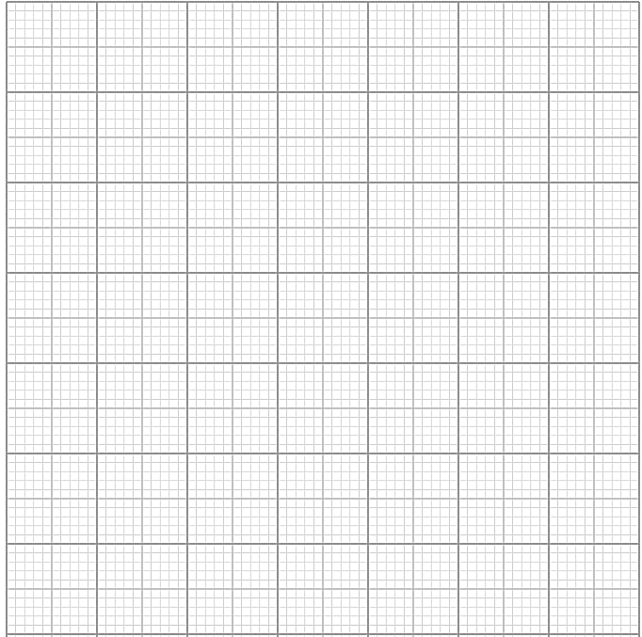

A spare grid is provided on Page 35. If you use the spare grid, cross out this attempt.

Question 3 (17 marks)

There are many ways in which researchers improve our knowledge of brain structure and function.

(a) State what information can be gained from a computed tomography and provide one example. (2 marks)
Information gained:

Example:

(b) Describe the process of an electroencephalogram (EEG). (2 marks)

(c) Compare magnetic resonance imaging (MRI) with functional magnetic resonance imaging (fMRI). (3 marks)

We are also able to learn much from historical research on the structure and function of the brain. For example, research on Phineas Gage has increased our knowledge of the brain.

(d) State the type of research conducted with Phineas Gage. (1 mark)

(e) Describe why this type of research is considered non-experimental. (2 marks)

(f) Outline two strengths and two limitations for this type of research. (4 marks)

Roger Sperry’s split-brain studies with animals and humans provided much insight into aspects of the brain.

(g) Recall Sperry’s findings on the role of the corpus callosum when working with humans. (3 marks)

Question 4 (6 marks)

As a researcher, you have been tasked with designing a study on physical movement of split-brain subjects. You will be giving participants a physical instruction (eg kick your left foot) into a single ear only, to see whether they are capable of following the instruction. You have 40 participants and will be tallying how many are able to follow the instruction for each ear.

(a) Identify the independent and dependent variables for your study. (2 marks)
Independent:

Dependent:

You use convenience sampling to gain participants for this study.

(b) (i) Define convenience sampling. (1 marks)

(ii) Outline two limitations to sampling participants in this way. (2 marks)

(iii) State the type of data being collected in this study. (1 marks)

Question 5 (26 marks)

Unlike many other areas, studies in development look at humans across the entire lifespan.

(a) List the last three stages of development in chronological order. (3 marks)
One:
Two:
Three:

(b) Explain the two types of motor skills studied when looking at physical development.
(6 marks)

(c) Define developmental plasticity. (1 mark)

Question 5 (continued)

During infancy, our brain goes through our greatest level of plasticity. It is during this age, more than any other, that the five stages of plasticity are in affect.

(d) Complete the table below detailing the stages of plasticity. (7 marks)

Name | Definition
 | first stage, cells destined to become neuron multiply
 | elimination of excess neuron growing out to target cells and form synapses with them
Myelination

Ame is an adolescent, his brain is going through a number of structural changes.

(e) Define adolescence. (1 mark)

(f) State one physical change to the corpus callosum during this period and identify the effect this change could have on Ame. (2 marks)

(g) Propose how changes in each of the following brain structures would effect Ame’s behaviour and/or emotion. (6 marks)
Amygdala:

Cerebellum:

Frontal lobe:

Question 6 (26 marks)

(a) Identify the area of development Piaget is most attributed to. (1 mark)

(b) Describe the term ‘schema’ within Piagetian theory. (2 marks)

(c) Define the term ‘disequilibrium’ and describe when a child may experience this.
(2 marks)

(d) Compare ‘accommodation’ and ‘assimilation’ in regards to schemas.
(3 marks)

Mav and Gix are brothers. They are watching a puppet show where two puppets fight over a drink of water while riding their bike. They experience the show differently. Mav is amazed each time one of the puppets reappears after having gone behind the stage curtains. Gix is getting frustrated because the puppets are fighting over different shaped cups but Gix says there is the same amount in each and there shouldn’t be a fight.

(e) Complete the table below outlining the two stages of Piaget’s theory of cognitive development most relevant to the brothers. (6 marks)

 | Mav | Gix
Stage name
Characteristics of stage
Example from scenario

Piaget’s pre-operational stage is characterised by animism and centration.

(f) Using the scenario the puppet show above, describe what a child in the
pre-operational stage might experience in regards to animism and centration.
(4 marks)
Animism:

Centration:

Question 6 (continued)

(g) Outline the Piagetian task known as three mountains and explain how it is used to determine developmental change. (5 marks)

(h) Evaluate whether the three mountains task is an accurate test to determine developmental changes. Justify your response. (3 marks)

END OF SECTION ONE

Section Two: Extended answers 30% (64 Marks)

Section Two consists of three questions.

Answer one question from Part A and one question from Part B.

Supplementary pages for planning/continuing your answers to questions are provided at the end of this Question/Answer booklet. If you use these pages to continue an answer, indicate at the original answer where the answer is continued, i.e. give the page number.

Suggested working time: 60 minutes

Part A 10% (30 marks)

This part has one compulsory question. Write your answer to Question 7 on pages 20–25. When you have answered this question, turn to page 26 for Question 8 and Question 9 and write your answer on pages 27-31.

Question 7 (30 marks)

Dru was intrigued by how messages travel around our body. In particular, he was interested in neurons and neural transmission. He decided to construct a presentation about neurons and neural transmission to present to his class.

Produce an outline of the information Dru should include in his presentation.

In your response you should:
- Outline the structure and function of a neuron. (10 marks)
- Discuss the three types of neurons and their functions. (6 marks)
- Outline the process of neural transmission, defining key terms. (10 marks)
- Use appropriate psychological terminology. (4 marks)

TURN TO PAGE 26 FOR SECTION 2 PART B (QUESTION 8 AND 9)

Part B 20% (34 marks)

Choose either Question 8 or Question 9.

Indicate the question you will answer by ticking the box next to the question. Write your answer on pages 27 – 32.

Question 8 (34 marks)

Attachment has been an area of interest for psychologists for many years, trying to understand the impact different types of attachment in infancy can have on our futures. The theory of attachment was outlined by Bowlby, while Harlow’s research had a keen impact on our understanding of what is most important to infants in attachment. However, Harlow’s study is largely unrepeatable now, due to animal rights when using animals in research.

In your response you should:
- Outline Bowlby’s theory of attachment, including defining key terms. (12 marks)
- Describe Harlow’s attachment study. (8 marks)
- Explain the use of animals in research, defining the three key terms. (10 marks)
- Communicates psychological understandings appropriately. (4 marks)

OR

Question 9 (34 marks)

Mer has raised her son, Heo, in a traditional Israeli fashion. Heo is displaying some unusual behaviours when he is separated from his mother. Mer decides she would like to do some research into Heo’s attachment in order to better understand him. Initially, she looked to Bowlby’s research into attachment, but found she wanted more understanding of his attachment type.
Outline some of the findings Mer would have found in her research that might suggest why Heo is displaying unusual behaviours upon separation.
In your response you should:
- Outline Bowlby’s theory of attachment, including defining key terms. (12 marks)
- Describe one study that measures attachment. (12 marks)
- Discuss findings about cross cultural patterns of attachment. (4 marks)
- Apply understandings of attachment to Mer and Heo. (2 marks)
- Use appropriate psychological terminology. (4 marks)

END OF QUESTIONS

Question number: _________________

Question number: _________________

Question number: _________________

Question number: _________________

Question number: _________________

Question number: _________________

Supplementary page

Question number:

Supplementary page

Question number:

Spare grid

